
University of Thessaly
Department of Computer Science and Biomedical Informatics

Bachelor’s thesis
Differential Methylation and Expression Analysis of MicroRNAs Across Various Cancer Types.

Undergraduate Student:
Konstantina Marita
Supervisor:
Professor Artemis G. Hatzigeorgiou

Lamia, 2026

INTODUCTION

1.1 DNA methylation and cancer.
DNA methylation, a mechanism that primarily occurs as an addition of a methyl group to the carbon-5 atom of cytosine in a cytosine-guanine (CpG) dinucleotide, is the most studied epigenetic modification in mammalian genomes. In normal cells, DNA methylation is precisely regulated and occupies an essential role in the maintenance and control of gene expression, X-chromosome inactivation and chromosomal stability. However, aberrant DNA methylation patterns have a detrimental effect in cancer, as they can lead to the silencing of tumor suppressor genes and the activation of oncogenic pathways, thereby contributing to cancer initiation, progression, and therapy resistance (Jones PA, Baylin SB. 2007).

1.2 Illumina Infinium HumanMethylation450 Array
Illumina Infinium HumanMethylation450 array, one of the most established genome-wide methylation profiling technologies, has enabled the characterization of cancer methylation patterns across thousands of clinical samples. The Cancer Genome Atlas (TCGA) is a large-scale, publicly available database that contains multi-omics molecular and clinical profiles for more than 20,000 primary malignancies and matched normal samples spanning 33 cancer types. TCGA enables comparative analysis between tumor and normal tissues, integrating high-throughput sequencing, gene expression and DNA methylation data for biomarker discovery and cancer research (The Cancer Genome Atlas Research Network., et al.).
This microarray platform interrogates 485,512 CpG sites across the human genome, covering approximately 99% of RefSeq genes (Goldfarb, T. et al. 2024) and 96% of CpG islands annotated on the UCSC genome database (Perez, G. et al. 2024). The array uses two distinct probe chemistry designs consisting of Infinium Type I probes, which employ separate bead types for methylated and unmethylated loci with two-color fluorescent detection, and Infinium Type II probes, which measure both methylation states on a single bead type through differential fluorescence. This design strategy enables extensive coverage across functionally critical genomic regions including proximal promoters, gene bodies, 3’ untranslated regions and CpG island shores (Illumina Inc., 2012). CpG island shores are genomic regions with low CpG density loacated up to 2 kilobases upstream or downstream of the CpG island boundaries (Irizarry et al, 2009).
Illumina HumanMethylation450 BeadChip measurements are converted to Beta-values, which quantify the methylation level on a CpG site as the ratio of the methylated probe intensity and the overall intensity (the total of methylated and unmethylated intensities). For a given CpG site i, the beta-value is defined as:


where y_{i,methy} and y_{i,unmethy} are the intensities measured by the i^{th} methylated and unmethylated probes, respectively. The max function ensures that any negative values will be reset to 0. Illumina
recommends adding a constant offset _{α} (typically _{α} = 100) to the denominator to regularize Beta value when both methylated and unmethylated probe intensities are low (Du, P., Zhang, X., Huang, C.C. et al. 2010).
The final output is a Beta-value array, where the rows represent each CpG site and the columns each sample of the dataset. Beta-values of the array range from 0 to 1, where 0 indicates complete absence of methylation, while a value of 1 shows complete methylation of a given CpG site on a specific sample.

1.3 MiRNAs, DNA methylation and their key role in cancer.
MicroRNAs (miRNAs) are small non-coding RNA sequences, approximately 22 nucleotides in length, that regulate gene expression at a post-transcriptional level (Bartel, 2009). More precisely, through sequence-specific binding to the complementary sites in 3’ untranslated regions of the target mRNA, miRNAs induce mRNA degradation and translational repression (Huntzinger & Izaurralde, 2011). In the context of cancer, miRNAs can act as tumor suppressors or oncogenes depending on the gene they are targeting (Peng & Croce, 2016).
The expression of miRNAs is highly regulated by epigenetic mechanisms, with DNA methylation being one of the most critical factors in controlling miRNA transcription. DNA methylation patterns in CpG islands within miRNA genes are frequently observed in cancer. Specifically, hypermethylation of CpG islands within miRNA genes can lead to the silencing of tumor suppressor miRNAs, while hypomethylation is linked with activation or overexpression of oncogenic miRNAs, therefore contributing to carcinogenesis, cancer progression and resistance to therapy (Lopez-Serra & Esteller, 2011).

1.4 MiRNA promoters, DNA methylation and their key role in cancer.
MiRNA promoters are regulatory DNA sequences typically located 1,000 base pairs upstream of miRNA gene bodies, extending approximately 100-200 base pairs downstream of the transcription start site (TSS) of the miRNA (Corcoran et al., 2009). These promoters share structural similarities with protein-coding gene promoters, including the presence of core promoter elements such as TATA boxes, CCAAT boxes, and CpG islands spanning 300-3000 bp, which work as binding locations for transcriptional proteins (Ozsolak et al., 2008).
The dysregulation of miRNA promoter activity plays a crucial role in cancer development and progression. Aberrant hypermethylation of CpG islands within miRNA promoter regions leads to transcriptional silencing of tumor suppressor miRNAs, preventing their expression and thus enabling oncogenic pathways (Lujambio et al., 2008). The hypomethylation of oncogenic miRNA promoters results in their overexpression, promoting cancer cell proliferation, survival, and metastasis. Additionally, mutations in transcription factor binding sites within miRNA promoters and alterations in the activity of transcriptional regulators further contribute to the dysregulated miRNA expression profiles observed across various cancer types (Di Leva et al., 2014).

1.5 Research Objective
The primary objective of this thesis is to investigate how DNA methylation patterns differ within miRNA gene regions across various types of cancer by performing a genome-wide analysis utilizing data from the TCGA database. More precisely, this research aims to identify differentially methylated CpG islands (DMC) and differentially methylayted regions (DMR) within miRNA gene loci by comparing cancerous to normal tissue samples. A DMC represents an individual CpG site in the genome with a statistically significant change in DNA methylation levels between two or more sample groups, such as tumor versus normal tissue. A DMR is a contiguous genomic region that contains multiple CpG islands that collectively display a consistent and statistically significant alteration in DNA methylation between two or more groups. (Maksimovic et all, 2016)
By applying comprehensive methylation profiling with miRNA gene annotations, this analysis seeks to characterize patterns of hypermethylation and hypomethylation affecting miRNA genes across different cancers. Through this approach, the study aims to highlight miRNAs whose altered methylation status may be associated with cancer initiation and progression.
Overall, this work provides a systematic framework for exploring miRNA-associated DNA methylation changes in cancer and contributes to the understanding of their potential relevance as candidate epigenetic biomarkers and therapeutic targets.

Materials and Methods

Data acquisition and preprocessing
The data used in this methylation analysis were acquired from the TCGA database. The entire analysis was performed using R, version 4.4.3. The package TCGAbiolinks (v2.34.1) was utilized to retrieve DNA methylation data for all available cancer types in the database. More specifically, methylation beta values generated from the Illumina Human Methylation 450K platform were downloaded and prepared using the GDCquery, GDCdownload, and GDCprepare functions. Then, detailed preprocessing was performed to ensure data integrity. More precisely, tissue-type annotations were standardized and only samples classified as “Solid Tissue Normal” or “Primary Solid Tumor” were retained for the analysis. Clinical data, including patient age and the sex, and the tissue type were downloaded and then summarized to derive descriptive statistics. These statistics included patient’s average age, gender distribution and tumor vs. normal sample distribution for each sample group.

Quality control, probe filtering and exploratory analysis.
The next step was to perform an exploratory analysis to assess data quality and potential cofounding factors. Pearson’s chi-square test was utilized to evaluate whether the distribution of tumor versus normal samples differed between male and female patients. Welch’s t-test was used to compare global mean DNA methylation levels between male and female patients. The results of the latter are visualized by boxplots while beta value distributions were assessed using density plots stratified by sample type. Finally, sample clustering was evaluated using multidimensional scaling (MDS).
Moreover, probe filtering was applied using sesame (v1.24.0) quality control metrics, which removed probes flagged for poor mapping, SNP overlap, or repetitive sequences, taking into consideration only canonical CpG probes. Also, probes located on sex chromosomes were excluded to eliminate sex-specific methylation effects, as well as probes with missing values across any samples to ensure complete data matrices.
After probe filtering, the overall distribution of CpG methylation was re-evaluated and the relationship between the samples was visualized. More precisely, the density of beta values for tumor and normal samples in the filtered probes in comparison to their overall methylation distribution was visualized by density plots, whereas MDS plots were utilized to determine whether tumor and normal samples are globally separated according to their methylation profiles.

Differential methylation analysis on individual CpG sites (DMC).
The differential methylation analysis of single DMC was conducted by using the TCGAanalyze_DMC() function from the TCGAbiolinks(v2.34.1) package. For each CpG site, this function compares the beta-values between primary tumor and normal tissue groups and assesses the statistical significance using the Wilcoxon rank-sum test, a non-parametric method used for comparing methylation data that may not follow normal distributions. Multiple testing correction using the Benjamini-Hochberg false discovery rate method was also applied. CpG sites were considered differentially methylated if they met a p-value threshold of 0.05 as well as an absolute difference in mean beta values of at least 0.1 between normal and tumor tissue samples. CpG sites that acquired a value greater than 0.1 were classified as hypermethylated, whereas the ones with a value less than -0.1 were considered hypomethylated in tumor samples relatively to normal ones. All significant CpG sites were annotated with their genomic coordinates and official gene symbols and were visualized in volcano plots showing methylation status (Δβ) against statistical significance (-log10 FDR).
The analysis continues with the identification of differentially methylated CpG probes that overlap with miRNA gene loci. In this part, a miRNA gene annotation BED file was imported and converted to GRanges object and the CpG probes tested were extracted from the DMC results. The function used to detect overlaps between probe ranges and miRNA coordinates was FindOverlaps and the resulting table, which included the overlapping probe IDs, genomic ranges, mean beta values for tumor and normal, FDR and methylation status, was produced. Additionally, a volcano plot was produced, visualizing the differentially methylated CpGs in the miRNA genes.

Differentially methylated regions discovery and analysis (DMR).
Differentially methylated regions were identified using the DMRcate package(v3.2.1), which detects contiguous genomic regions that show coordinated differences between tumor and normal samples. Firstly, a phenotype factor was built indicating both Solid Tissue Normal and Primary Solid Tumor samples and was used to construct a design matrix for the tumor-normal comparison. Additionally, with the aim of comparing the methylation differences at probe-level between the two sample groups, a comparison matrix was defined using makeContrasts.
A GenomicRatioSet object by minfi (v1.52.1), a Bioconductor class that combines methylation values with genomic coordinates and sample metadata, was constructed using the filtered methylation data. More precisely, the object was built by combining the beta values matrix, the genomic ranges of each CpG probe and the corresponding sample phenotype data. The annotation was set to the Illumina HumanMethylation450K platform with the ilmn12.hg19 manifest, which provided probe-level genomic coordinates and gene annotations based on the hg19 human reference genome.
Statistics were later calculated at probe level using the cpg.annotate function from DMRcate(v3.2.1), which analyzed beta values from the IlluminaHumanMethylation450k array and performed differential methylation analysis between tumor and normal samples. To specify the comparison between normal and tumor samples, the previously constructed matrices were utilized. At this step, linear models were fitted to each CpG site using the limma package (v3.62.2) (Ritchie et al. 2015) and the statistical significance was calculated with moderated t-statistics.
The next step was to extract the statistically significant regions and classify them as hypermethylated or hypomethylated based on the sign of their median methylation difference (median Δβ). Volcano plots were then generated to summarize the relationship between effect size and statistical significance (-log10 FDR) across all regions. Finally, summary counts of hypermethylated, hypomethylated and total DMRs were obtained for each cancer type.
Next, the analysis continues with the identification of DMRs that overlap with known miRNA genes. The DMR genomic coordinates were converted into a GRanges object and miRNA gene annotations were imported from a BED file. Overlaps between DMRs and miRNA genes were identified with the findOverlaps function and merged with the DMR results table, keeping only those DMRs that overlapped with at least one miRNA gene. The final output file included the DMR identifiers, overlapping miRNA genes, genomic coordinates, length and number of CpG probes, FDR, median and methylation status classification. Additionally, a volcano plot was generated to visualize the results.

6. Coordinate-Based Identification of overlapping DMRs across different cancer types and miRNAs.
To identify DMRs that are consistent across multiple types of cancer and overlap with miRNA gene bodies, we employed a custom R script (v.4.4.3) using the dplyr (v.1.1.4), ggplot2 (v. 3.5.1), and pheatmap (v.1.0.12) packages. For each cancer type, significant DMRs located within miRNA gene regions were extracted from the previous analysis, retaining only the ones with a significant methylation status and excluding those with a “ Not Significant ” status.
Quality control was then applied to each dataset to remove entries with missing values such as wrong or missing genomic coordinates. The filtered coordinates of hypermethylated or hypomethylated DMRs from each cancer type were then merged into a unified dataset, preserving metadata including cancer type, DMR index, associated miRNA and methylation status.
To identify DMRs with identical genomic locations across multiple cancers, unique genomic coordinate identifiers were generated for each DMR which included the chromosome, starting position and ending position. DMRs sharing the same genomic coordinates were grouped across all cancer types and only the ones present in 2 or more cancers were retained for more analysis.
For each DMR present in 2 or more cancers, the directionality of methylation was evaluated to determine concordance. DMRs were classified as “All hypermethylated” when all DMR appearances in multiple cancers exhibited hypermethylation, “All hypomethylated” when all instances displayed hypomethylation and “Discordant” when the directions of methylation were mixed. A matrix was then constructed with miRNAs as rows and cancer types as columns where each entry represented the count of unique DMRs overlapping with miRNA gene bodies in different cancer types.
For each miRNA we calculated the number of concordant DMRs across all cancer types, the number of hypermethylated and hypomethylated DMRs, and the number of specific cancer types affected.
Moreover, statistical visualizations were generated using ggplot2 (v. 3.5.1) such as bar plots displaying the frequency distribution of DMRs by number of cancer types, top 20 miRNAs by total concordant DMR count, chromosomal distribution of concordant DMRs and lastly, the total number of DMRs per cancer type. The top 50 miRNAs by total number of DMRs were visualized with a heatmap using pheatmap (v.1.0.12). The heatmap color scale ranged from white, meaning no DMRs, to dark red, showing the maximum amount of DMRs, to visualize the intensity and pattern of DMR occurrences.

RESULTS

3.1 Data selection.
The data used in this research was acquired from the TCGA database, which offers methylation beta-values for 33 different types of cancer. However, in this thesis only 22 types were studied. The exclusion of 11 datasets was due to missing values and thus incompleteness. Some notable examples of incomplete datasets include DLBC (Diffuse Large B-cell Lymphoma), MESO (Mesothelioma), UVM (Uveal Melanoma) and TGCT (Testicular Germ Cell Tumors) datasets, which lacked normal tissue samples, a critical component of the comparative methylation analysis. Moreover, the remaining excluded datasets exhibited other limitations such as insufficient methylation data, inadequate sample sizes, or missing clinical annotations. Therefore, to ensure the quality of the data and analysis, only the 22 types of cancer with both tumor and normal samples and complete methylation profiles were retained for this study.

3.2 Paired vs. Unpaired analysis
The initial purpose of this research was to apply paired statistical testing, where both the tumor and the normal tissue samples stem from the same patient. Paired analysis is commonly utilized in cancer methylation studies as it uses each patient as their own control and thus, increasing statistical accuracy due to the decrease of environmental and genetic factors. However, while conducting the methylation analysis, significant limitations in paired samples in the TCGA datasets were observed, leading to data with low significance. Thus, unpaired analysis was employed, which entails the comparison between independent tumor and normal tissue samples originating from two different groups. This type of analysis is consistent with big-scale TCGA methylation studies and maximizes statistical power by utilizing the whole dataset while ensuring adequate sample sizes for reliable methylation detection. (Brorson et al. 2022)

3.3 Overview of data and visualizations.
The first step in the research was to apply the differential methylation analysis script to 22 of the 33 cancer types in the TCGA database. We used methylation beta values of tumor and normal samples that derived from the Illumina Methylation 450K array.
The differential methylation analysis produced seven plots:
- a global mean methylation by sex box plot
- a density plot of beta values
- a MDS plot of methylation data
- a volcano plot of DMCs
- a volcano plot of DMCs that overlap with miRNA genes
- a volcano plot of DMRs
- a volcano plot of DMRs that overlap with miRNA genes
Moreover, the analysis produced four TSV files:
- a TSV file containing DMCs,
- a TSV file containing DMCs that overlap with miRNA genes,
- a TSV file containing DMRs,
- a TSV file containing DMRs that overlap with miRNA genes.

3.4 Detailed results for each tested cancer type.
In this study, DNA methylation data from 22 cancer types from the TCGA database were analyzed, consisting of 6,922 primary tumor samples and 691 normal tissue samples (Table 3.1). Sample sizes varied from the largest cohort (BRCA) having 793 tumor samples to the smallest (CHOL) having 36 tumor samples. Normal tissue availability varied from 160 normal samples (KIRC) to 2 normal samples (GBM, STAD, SKCM, THYM).
Sex distribution reflected sex-specific cancers (UCEC, PRAD, CESC) and sex-related patterns with varying male-to-female ratios. Patient age at diagnosis ranged from 47.7 to 68.2 years across cancer types, with the youngest cohorts being PCPG and CESC (47.7 and 48.8 years) and the oldest being BLCA and LUSC (68.2 and 68.1 years).
Chi-squared tests were performed to assess whether the distribution of tumor to normal samples varied according to patient sex across the different cancer types (Table 3.2). Values such as $χ^{2}$, p-value and df were calculated, revealing sex-specific cancers with significant associations. Three sex-specific cancers (CESC, PRAD, UCEC) showed highly significant associations (p-value <2.2e-16), whereas the remaining cancer types displayed no significant or only nominally significant associations.
Differential methylation analysis was also performed (Table 3.3), identifying DMCs and DMRs for each of the cancer types studied. The analysis revealed hypermethylation and hypomethylation predominance, offering methylation profiles for cancer type.
The analysis was extended into the identification of statistically significant DMCs and DMRs present in miRNA gene bodies and promoters, focusing on the hypermethylated and hypomethylated DMCs and DMRs that are present in cancer types and overlap with miRNAs. This step of the analysis offered us an insight on the important role of miRNAs in gene regulation and cancer proliferation and development.

Table 3.1: Clinical and demographic characteristics of TCGA cancer cohorts analyzed in this study.
Cancer Type | Tumor | Normal | Female | Male | Average Age
 | Samples | Samples |  |  | (years)
Liver Hepatocellular Cancer (LIHC) | 377 | 50 | 119 | 248 | 59.8
Breast Cancer (BRCA) | 793 | 97 | 780 | 9 | 59.0
Bladder Cancer (BLCA) | 418 | 21 | 108 | 304 | 68.2
Cervical Squamous Cell Carcinoma (CESC) | 307 | 3 | 307 | 0 | 48.8
Cholangiocarcinoma (CHOL) | 36 | 9 | 20 | 16 | 63.5
Colon Adenocarcinoma (COAD) | 312 | 38 | 136 | 157 | 65.3
Esophageal Carcinoma (ESCA) | 185 | 16 | 27 | 158 | 62.7
Glioblastoma Multiforme (GBM) | 140 | 2 | 58 | 80 | 61.1
Head and Neck Squamous Cell Carcinoma (HNSC) | 528 | 50 | 142 | 386 | 61.5
Lung Adenocarcinoma (LUAD) | 473 | 32 | 246 | 215 | 65.4
Lung Squamous Cell Carcinoma (LUSC) | 370 | 42 | 96 | 276 | 68.1
Pancreatic Adenocarcinoma (PAAD) | 184 | 10 | 82 | 102 | 65.2
Pheochromocytoma and Paraganglioma (PCPG) | 179 | 3 | 101 | 78 | 47.7
Prostate Adenocarcinoma (PRAD) | 502 | 50 | 0 | 498 | 61.7
Rectum Adenocarcinoma (READ) | 98 | 7 | 44 | 53 | 63.4
Sarcoma (SARC) | 261 | 4 | 142 | 119 | 61.3
Stomach Adenocarcinoma (STAD) | 395 | 2 | 139 | 259 | 65.7
Skin Cutaneous Melanoma (SKCM) | 104 | 2 | 42 | 64 | 65.6
Kidney Renal Papillary Cell Carcinoma (KIRP) | 275 | 45 | 73 | 202 | 61.7
Thymoma (THYM) | 124 | 2 | 60 | 64 | 58.7
Kidney Renal Clear Cell Carcinoma (KIRC) | 324 | 160 | 114 | 205 | 61.8
Uterine Corpus Endometrial Carcinoma (UCEC) | 438 | 46 | 432 | 0 | 64.6

Table 3.2: Chi-squared test results for the association between sex and tissue type (tumor vs. normal) across TCGA cancer cohorts.
Cancer Type | X-squared | df | p-value
Liver Hepatocellular Cancer (LIHC) | 0.821 | 1 | 0.365
Breast Cancer (BRCA) | 0.268 | 1 | 0.605
Bladder Cancer (BLCA) | 3.559 | 1 | 0.059
Cervical Squamous Cell Carcinoma (CESC) | 298.12 | 1 | <2.2e-16
Cholangiocarcinoma (CHOL) | 0.673 | 1 | 0.412
Colon Adenocarcinoma (COAD) | 0.285 | 2 | 0.867
Esophageal Carcinoma (ESCA) | 4.085 | 1 | 0.043
Glioblastoma Multiforme (GBM) | 2.70e-30 | 1 | 1.000
Head and Neck Squamous Cell Carcinoma (HNSC) | 0.076 | 1 | 0.783
Lung Adenocarcinoma (LUAD) | 0.320 | 1 | 0.572
Lung Squamous Cell Carcinoma (LUSC) | 0.263 | 1 | 0.608
Pancreatic Adenocarcinoma (PAAD) | 6.25e-31 | 1 | 1.000
Pheochromocytoma and Paraganglioma (PCPG) | 0.045 | 1 | 0.8316
Prostate Adenocarcinoma (PRAD) | 370.12 | 1 | <2.2e-16
Rectum Adenocarcinoma (READ) | 0.440 | 2 | 0.803
Sarcoma (SARC) | 0.099 | 1 | 0.753
Stomach Adenocarcinoma (STAD) | 1.435 | 1 | 0.231
Skin Cutaneous Melanoma (SKCM) | 0.182 | 1 | 0.670
Kidney Renal Papillary Cell Carcinoma (KIRP) | 0.209 | 1 | 0.647
Thymoma (THYM) | 0.541 | 1 | 0.462
Kidney Renal Clear Cell Carcinoma (KIRC) | 0.044 | 1 | 0.833
Uterine Corpus Endometrial Carcinoma (UCEC) | 345.80 | 1 | <2.2e-16

Table 3.3: Summary of differentially methylated CpG sites (DMCs) and differentially methylated regions (DMRs). Differential methylation was assessed at FDR < 0.05 and |∆_{β| ≥} 0.1 for DMCs, and FDR < 0.05 for DMRs.

Cancer Type |  | DMCs |  | DMRs
 | Hyper | Hypo | Total | Hyper | Hypo | Total
LIHC | 15,197 | 60,394 | 294,792 | 1,455 | 8,822 | 40,031
BRCA | 37,960 | 25,379 | 292,495 | 4,346 | 3,170 | 39,806
BLCA | 22,952 | 65,354 | 326,030 | 2,498 | 9,124 | 41,193
CESC | 0 | 0 | 302,629 | 5,386 | 4,594 | 41,273
CHOL | 30,685 | 10,336 | 353,556 | 4,906 | 1,312 | 43,388
COAD | 29,662 | 34,252 | 303,901 | 3,722 | 4,053 | 41,667
ESCA | 30,434 | 31,072 | 342,014 | 3,668 | 4,040 | 42,520
GBM | 0 | 0 | 327,021 | 1,416 | 1,335 | 42,132
HNSC | 34,356 | 39,685 | 325,410 | 3,507 | 5,194 | 41,653
LUAD | 33,243 | 28,793 | 322,968 | 3,481 | 3,243 | 41,750
LUSC | 28,038 | 45,774 | 307,855 | 3,056 | 6,106 | 40,124
PAAD | 22,395 | 15,994 | 330,957 | 2,276 | 1,449 | 41,711
PCPG | 0 | 0 | 367,946 | 1,265 | 5,029 | 43,968
PRAD | 44,971 | 14,379 | 335,747 | 4,782 | 1,441 | 42,248
READ | 22,094 | 49,635 | 364,444 | 2,644 | 7,364 | 43,788
SARC | 0 | 0 | 303,632 | 451 | 1,595 | 39,768
STAD | 0 | 0 | 304,454 | 241 | 441 | 40,290
SKCM | 0 | 0 | 321,747 | 1,764 | 1,167 | 41,033
KIRP | 35,634 | 10,613 | 346,350 | 3,205 | 809 | 43,097
THYM | 0 | 0 | 350,879 | 19 | 8 | 42,967
KIRC | 20,028 | 22,573 | 322,539 | 1,734 | 1,895 | 41,295
UCEC | 34,493 | 45,844 | 309,604 | 3,978 | 6,370 | 40,860

Table 3.4: Summary of significantly differentially methylated CpG sites (DMCs) and differentially methylated regions (DMRs) in miRNA gene bodies.
Cancer Type |  | DMCs |  | DMRs
 | Hyper | Hypo | Total | Hyper | Hypo | Total
LIHC | 407 | 1267 | 9448 | 63 | 353 | 1890
BRCA | 1137 | 850 | 9272 | 181 | 185 | 1885
BLCA | 659 | 1292 | 10267 | 103 | 389 | 1926
CESC | 0 | 0 | 9558 | 215 | 221 | 1922
CHOL | 873 | 286 | 11030 | 203 | 64 | 2033
COAD | 946 | 1102 | 116445 | 98 | 122 | 1283
ESCA | 924 | 992 | 10715 | 163 | 175 | 1983
GBM | 0 | 0 | 10295 | 87 | 62 | 1968
HNSC | 957 | 1159 | 10232 | 158 | 222 | 1962
LUAD | 1024 | 762 | 10145 | 153 | 136 | 1954
LUSC | 846 | 1217 | 9711 | 137 | 272 | 1886
PAAD | 544 | 536 | 10448 | 86 | 69 | 1974
PCPG | 0 | 0 | 11378 | 88 | 227 | 2060
PRAD | 1113 | 518 | 10518 | 195 | 73 | 1971
READ | 639 | 1156 | 11323 | 91 | 301 | 2053
SARC | 0 | 0 | 9627 | 23 | 69 | 1881
STAD | 0 | 0 | 9600 | 16 | 23 | 1887
SKCM | 0 | 0 | 10157 | 112 | 67 | 1922
KIRP | 1108 | 323 | 10820 | 176 | 47 | 2015
THYM | 0 | 0 | 10980 | 1 | 0 | 2026
KIRC | 642 | 748 | 10134 | 78 | 98 | 1941
UCEC | 1047 | 1207 | 9782 | 175 | 294 | 1910

Table 3.4: Summary of significantly differentially methylated CpG sites (DMCs) and differentially methylated regions (DMRs) in miRNA promoters region.
Cancer Type |  | DMCs |  | DMRs
 | Hyper | Hypo | Total | Hyper | Hypo | Total
LIHC | 49 | 203 | 1170 | 29 | 103 | 935
BRCA | 109 | 81 | 1155 | 72 | 48 | 936
BLCA | 47 | 217 | 1295 | 47 | 106 | 941
CESC | 0 | 0 | 1167 | 99 | 91 | 955
CHOL | 69 | 31 | 1356 | 83 | 30 | 980
COAD | 74 | 99 | 1148 | 75 | 52 | 950
ESCA | 71 | 101 | 1327 | 63 | 51 | 961
GBM | 0 | 0 | 1248 | 43 | 28 | 948
HNSC | 69 | 113 | 1261 | 58 | 61 | 958
LUAD | 62 | 92 | 1266 | 61 | 41 | 956
LUSC | 58 | 172 | 1239 | 56 | 75 | 942
PAAD | 56 | 53 | 1282 | 44 | 20 | 952
PCPG | 0 | 0 | 1404 | 25 | 68 | 981
PRAD | 143 | 42 | 1298 | 75 | 15 | 963
READ | 35 | 172 | 1404 | 47 | 94 | 986
SARC | 0 | 0 | 1220 | 11 | 17 | 938
STAD | 0 | 0 | 1193 | 7 | 17 | 934
SKCM | 0 | 0 | 1275 | 48 | 27 | 944
KIRP | 111 | 32 | 1328 | 53 | 11 | 974
THYM | 0 | 0 | 1362 | 0 | 0 | 973
KIRC | 42 | 66 | 1266 | 23 | 24 | 959
UCEC | 94 | 135 | 1213 | 57 | 65 | 963

3.4 Detailed analysis of each cancer type.

Liver Hepatocellular Carcinoma (LIHC)
The LIHC cohort consisted of 377 primary tumor samples and 50 normal tissue samples, with almost 2 times more male than female patients (119 female and 248 male). The average age of the patients at diagnosis was 59.8 years.
Chi-squared analysis revealed no significant association between sample type distribution and sex (χ² = 0.821 and p-value=0.365), indicating that the distribution of tumor and normal samples was independent of patient sex.
LIHC exhibited 75,591 DMCs out of the 294,792 CpG sites tested, consisting of 15,197 hypermethylated and 60,394 hypomethylated CpG sites, indicating a pronounced hypomethylation bias. Moreover, 10,277 DMRs were identified out of the 40,031 regions tested, where 1,455 of them were hypermethylated and 8,822 were hypomethylated. The strong hypomethylation pattern that was observed in the DMC analysis is maintained in the DMR analysis, confirming that global hypomethylation is a predominant epigenetic alteration in hepatocellular carcinoma.
In this type of cancer, 407 hypermethylated and 1,267 hypomethylated DMCs, as well as 63 hypermethylated and 353 hypomethylated DMRs, were found to overlap with miRNA gene bodies, totaling 1,674 DMCs and 416 DMRs. The pronounced hypomethylation bias observed in miRNA gene bodies mirrors the global methylation pattern in LIHC. Additionally, analysis of miRNA promoter regions revealed 49 hypermethylated and 203 hypomethylated DMCs, along with 29 hypermethylated and 103 hypomethylated DMRs, representing 252 total DMCs and 132 total DMRs. The data clearly show that hypomethylation affects both miRNA gene bodies and their promoter regions in liver cancer, indicating that loss of methylation is a primary mechanism driving miRNA dysregulation in this disease.

Breast Cancer (BRCA)
The BRCA cohort contained 793 primary tumor samples as well as 97 normal tissue samples, predominantly from female patients (780 female and 9 male). The average age of the patients at the time of diagnosis was 59 years.
Chi-squared analysis revealed no significant association between sample type distribution and sex (χ² = 0.268 and p-value=0.605), confirming that the distribution of tumor and normal samples were balanced between female and male patients.
BRCA displayed 63,339 DMCs out of the 292,495 sites analyzed, containing 37,960 hypermethylated and 25,379 hypomethylated CpG sites. Also, it exhibited 7,516 DMRs out of the 39,806 regions tested, consisting of 4,346 hypermethylated and 3,170 hypomethylated regions. Both analyses showed a slight hypermethylation predominance, indicating that hypermethylation is a critical epigenetic alteration in breast cancer.
In this type of cancer, 1,137 hypermethylated and 850 hypomethylated DMCs, as well as 181 hypermethylated and 185 hypomethylated DMRs, were found to overlap with miRNA gene bodies, totaling 1,987 DMCs and 366 DMRs. The hypermethylation predominance in miRNA gene bodies is consistent with the global methylation pattern observed in BRCA. Furthermore, examination of miRNA promoter regions identified 109 hypermethylated and 81 hypomethylated DMCs, together with 72 hypermethylated and 48 hypomethylated DMRs, representing 190 total DMCs and 120 total DMRs. Both miRNA gene bodies and promoter regions exhibit preferential hypermethylation in breast cancer, suggesting that epigenetic silencing through DNA methylation is a key mechanism for miRNA inactivation in this malignancy.

Bladder Cancer (BLCA)
The BLCA cohort comprised of 418 primary tumor samples and 21 normal tissue samples, with 3 times more male than female patients (108 female and 304 male). The average age of patients at the time of diagnosis was 68.2 years.
Chi-squared analysis revealed a trend toward sex-based sampling differences (χ² = 3.559 and p-value=0.059). While χ² approached a critical value of 3.84 for df=1, these differences in sample distribution between the two sexes were not deemed statistically significant (p-value=0.059).
BLCA exhibited 88,306 DMCs out of 326,030 sites analyzed, comprised 22,952 hypermethylated and 65,354 hypomethylated sites. The DMR analysis revealed 11,622 DMRs out of 41,193 regions tested, which included 2,498 hypermethylated and 9,124 hypomethylated regions. Both analyses displayed a hypomethylation bias, confirming that hypomethylation is a dominant epigenetic factor for bladder cancer.
In this type of cancer, 659 hypermethylated and 1,292 hypomethylated DMCs, as well as 103 hypermethylated and 389 hypomethylated DMRs, were found to overlap with miRNA gene bodies, totaling 1,951 DMCs and 492 DMRs. The hypomethylation predominance in miRNA gene bodies reflects the global methylation landscape in BLCA. In addition, analysis of miRNA promoter regions revealed 47 hypermethylated and 217 hypomethylated DMCs, accompanied by 47 hypermethylated and 106 hypomethylated DMRs, representing 264 total DMCs and 153 total DMRs. Hypomethylation dominates both miRNA gene bodies and promoter regions in bladder cancer, indicating that demethylation-mediated activation of miRNA expression is a major epigenetic mechanism in this disease.

Cervical Squamous Cell Carcinoma (CESC)
The CESC cohort contained 307 primary tumor samples and 3 normal tissue samples, with all the samples exclusively from female patients (307 female and 0 male). The average age of the patients at diagnosis was 48.8 years.
Chi-squared tests revealed a strong association between sample type distribution and sex (χ² = 298.12 and p-value<2.2e-16), reflecting the exclusive occurrence of cervical cancer in female patients, as it would be expected in a female specific cancer.
Despite analyzing 302,629 CpG sites, no significant DMCs were identified. However, CESC exhibited 9,980 DMRs out of the 41,273 regions tested, consisting of 5,386 hypermethylated and 4,594 hypomethylated regions.
In this type of cancer, 215 hypermethylated and 221 hypomethylated DMRs were found to overlap with miRNA gene bodies, totaling 436 DMRs. The relatively balanced distribution of hypermethylated and hypomethylated DMRs in miRNA gene bodies contrasts with the absence of significant individual CpG alterations, suggesting that regional methylation changes rather than single-site alterations characterize miRNA dysregulation in cervical cancer. Additionally, examination of miRNA promoter regions identified 99 hypermethylated and 91 hypomethylated DMRs, representing 190 total DMRs. Cervical cancer shows balanced regional methylation changes in both miRNA gene bodies and promoters without significant single CpG alterations, demonstrating that miRNA regulation in this cancer type operates primarily through broader regional methylation shifts.

Cholangiocarcinoma (CHOL)
The CHOL cohort consisted of 36 primary tumor samples and 9 normal tissue samples, with a relatively balanced sex distribution of 20 female and 16 male patients. The average age of the patients at diagnosis was 63.5 years.
Chi-squared analysis revealed no significant association between sample type distribution and sex (χ² = 0.673 and p-value=0.412), indicating that the distribution of tumor and normal samples was independent of patient sex.
CHOL displayed 41,021 DMCs out of the 302,629 CpG sites tested, consisting of 30,685 hypermethylated and 10,336 hypomethylated sites. DMR analysis identified 6,218 DMRs out of 43,388 regions tested, including 4,906 hypermethylated and 1,312 hypomethylated regions. In both cases, a strong hypermethylation dominance is observed, verifying that hypermethylation has a significant role in cholangiocarcinoma.
In this type of cancer, 873 hypermethylated and 286 hypomethylated DMCs, as well as 203 hypermethylated and 64 hypomethylated DMRs, were found to overlap with miRNA gene bodies, totaling 1,159 DMCs and 267 DMRs. The strong hypermethylation bias in miRNA gene bodies is consistent with the global methylation profile observed in CHOL. Moreover, analysis of miRNA promoter regions revealed 69 hypermethylated and 31 hypomethylated DMCs, together with 83 hypermethylated and 30 hypomethylated DMRs, representing 100 total DMCs and 113 total DMRs. Hypermethylation is the dominant pattern across both miRNA gene bodies and promoters in cholangiocarcinoma, demonstrating that methylation-mediated silencing is a central mechanism of miRNA inactivation in this cancer.

Colon Adenocarcinoma (COAD)
The COAD cohort comprised 312 primary tumor samples and 38 normal tissue samples, with a relatively balanced sex distribution of 136 female and 157 male patients. The average age of the patients at diagnosis was 65.3 years.
Chi-squared analysis revealed no significant association between sample type distribution and sex (χ² = 0.285 and p-value=0.867), indicating that the distribution of tumor and normal samples was balanced between the male and female patients.
COAD displayed 63,914 DMCs out of 303,901 sites tested, containing 29,662 hypermethylated and 34,252 hypomethylated CpG sites. It also exhibited 7,775 DMRs out of 41,667 regions analyzed, consisting of 3,722 hypermethylated and 4,053 hypomethylated regions. COAD revealed a slight hypomethylation predominance in both analyses, confirming the significance of hypomethylation as an epigenetic alteration.
In this type of cancer, 946 hypermethylated and 1,102 hypomethylated DMCs, as well as 98 hypermethylated and 122 hypomethylated DMRs, were found to overlap with miRNA gene bodies, totaling 2,048 DMCs and 220 DMRs. The modest hypomethylation predominance in miRNA gene bodies aligns with the overall methylation pattern in COAD. Additionally, examination of miRNA promoter regions identified 74 hypermethylated and 99 hypomethylated DMCs, along with 75 hypermethylated and 52 hypomethylated DMRs, representing 173 total DMCs and 127 total DMRs. While miRNA gene bodies show modest hypomethylation, the promoter regions display more complex patterns with regional hypermethylation in DMRs, indicating that colon cancer employs distinct methylation strategies at different functional elements of miRNA genes.

Esophageal Carcinoma (ESCA)
The ESCA cohort consisted of 185 primary tumor samples as well as 16 normal tissue samples, with almost 6 time more male than female patients (27 female and 158 male). The average age of the patients at diagnosis was 62.7 years.
Chi-squared analysis revealed a nominally significant association between sample type distribution and sex (χ² = 4.085 and p-value=0.043), suggesting a modest sex-based difference in sampling patterns.
ESCA exhibited 61,506 DMCs out of the 342,014 CpG sites tested, including 30,434 hypermethylated and 31,072 hypomethylated sites. DMR analysis showed 7,708 DMRs out of 42,520 regions, consisting of 3,668 hypermethylated and 4,040 hypomethylated regions. Both analyses displayed a balanced ration of hypermethylation and hypomethylation, revealing that both epigenetic mechanisms contribute equally to the development of esophageal carcinoma.
In this type of cancer, 924 hypermethylated and 992 hypomethylated DMCs, as well as 163 hypermethylated and 175 hypomethylated DMRs, were found to overlap with miRNA gene bodies, totaling 1,916 DMCs and 338 DMRs. The balanced distribution of hypermethylated and hypomethylated alterations in miRNA gene bodies mirrors the global methylation equilibrium observed in ESCA. Furthermore, analysis of miRNA promoter regions revealed 71 hypermethylated and 101 hypomethylated DMCs, together with 63 hypermethylated and 51 hypomethylated DMRs, representing 172 total DMCs and 114 total DMRs. Esophageal carcinoma shows relatively balanced methylation changes across both miRNA gene bodies and promoters, demonstrating that both hypermethylation and hypomethylation contribute to miRNA dysregulation in this disease.

Glioblastoma Multiforme (GBM)
The GBM cohort included 140 primary tumor samples and 2 normal tissue samples, which derived from 58 female and 80 male patients. The average age of patients at diagnosis was 61.1 years.
Chi-squared tests revealed no association between sample type distribution and sex (χ² = 2.70e-30 and p-value=1.000), indicating essentially perfect independence of sample distribution between female and male patients.
Even though GBM displayed no significant DMCs after testing 327,021 CpG sites, it exhibited 2,751 DMRs out of 42,132 regions analyzed. The DMRs consisted of 1,416 hypermethylated and 1,335 hypomethylated regions.
In this type of cancer, 87 hypermethylated and 62 hypomethylated DMRs were found to overlap with miRNA gene bodies, totaling 149 DMRs. The relatively balanced distribution with a slight hypermethylation predominance in miRNA gene body DMRs is consistent with the overall regional methylation pattern in GBM. Additionally, examination of miRNA promoter regions identified 43 hypermethylated and 28 hypomethylated DMRs, representing 71 total DMRs. Glioblastoma shows modest regional methylation changes with a slight hypermethylation bias in both miRNA gene bodies and promoters, but the absence of single CpG alterations indicates that regional methylation shifts are the primary mode of miRNA regulation in this cancer.

Head and Neck Squamous Cell Carcinoma (HNSC)
The HNSC cohort contained 528 primary tumor samples and 50 normal tissue samples, with 2.5 times more male than female patients (142 female and 386 male). The average age of the patients at diagnosis was 61.5 years.
Chi-squared analysis revealed no significant association between sample type distribution and sex (χ² = 0.076 and p-value=0.783), indicating that the distribution of tumor and normal samples was independent of patient sex.
HNSC exhibited 74,041 DMCs out of 325,410 CpG sites tested, including 34,356 hypermethylated and 39,685 hypomethylated sites. DMR analysis revealed 8,701 DMRs out of 41,653 regions tested, consisting of 3,507 hypermethylated and 5,194 hypomethylated regions. Both analyses suggest that hypomethylation is slightly more prominent in head and neck squamous cell carcinoma.
In this type of cancer, 957 hypermethylated and 1,159 hypomethylated DMCs, as well as 158 hypermethylated and 222 hypomethylated DMRs, were found to overlap with miRNA gene bodies, totaling 2,116 DMCs and 380 DMRs. The hypomethylation predominance in miRNA gene bodies is consistent with the global methylation landscape in HNSC. Moreover, analysis of miRNA promoter regions revealed 69 hypermethylated and 113 hypomethylated DMCs, accompanied by 58 hypermethylated and 61 hypomethylated DMRs, representing 182 total DMCs and 119 total DMRs. Hypomethylation is the dominant trend in miRNA gene bodies and is also evident in promoter region DMCs, though promoter DMRs show a more balanced pattern, indicating that demethylation-mediated miRNA activation plays a significant role in head and neck cancer.

Lung Adenocarcinoma (LUAD)
The LUAD cohort consisted of 473 primary tumor samples and 32 normal tissue samples, with a relatively balanced sex distribution of 246 female and 215 male patients. The average age of patients at diagnosis was 65.4 years.
Chi-squared analysis revealed no significant association between sample type distribution and sex (χ² = 0.320 and p-value=0.572), suggesting that the distribution of tumor and normal samples was not based on patient sex.
LUAD showed 62,036 DMCs out of 322,968 CpG sites tested, containing 33,243 hypermethylated and 28,793 hypomethylated sites. It also exhibited 6,724 DMRs out of 41,750 regions tested, including 3,481 hypermethylated and 3,243 hypomethylated regions. Both analyses displayed a balanced ration of hypermethylation and hypomethylation, revealing that both epigenetic mechanisms contribute equally to the development of lung adenocarcinoma.
In this type of cancer, 1,024 hypermethylated and 762 hypomethylated DMCs, as well as 153 hypermethylated and 136 hypomethylated DMRs, were found to overlap with miRNA gene bodies, totaling 1,786 DMCs and 289 DMRs. Interestingly, while the global methylation pattern is balanced, miRNA gene bodies show a moderate hypermethylation predominance, suggesting selective hypermethylation of miRNA-coding sequences in LUAD. Furthermore, examination of miRNA promoter regions identified 62 hypermethylated and 92 hypomethylated DMCs, together with 61 hypermethylated and 41 hypomethylated DMRs, representing 154 total DMCs and 102 total DMRs. Lung adenocarcinoma shows divergent methylation patterns between miRNA gene bodies (preferentially hypermethylated) and promoter regions (variable patterns), demonstrating that different regulatory mechanisms operate at distinct functional elements of miRNA genes in this cancer.

Lung Squamous Cell Carcinoma (LUSC)
The LUSC cohort comprised 370 primary tumor samples and 42 normal tissue samples, with three times more male than female patients (96 female and 276 male). The average age of patients at diagnosis was 68.1 years.
Chi-squared analysis revealed no significant association between sample type distribution and sex (χ² = 0.263 and p-value=0.608), indicating that the distribution of tumor and normal samples was balanced between the male and female patients.
LUSC displayed 73,812 DMCs out of 307,855 CpG sites tested, consisting of 28,038 hypermethylated and 45,774 hypomethylated sites. DMR analysis revealed 9,162 DRMs out of 40,124 total regions analyzed, including 3,056 hypermethylated and 6,106 hypomethylated regions. Both analyses confirm that hypomethylation is a predominant epigenetic factor in lung squamous cell carcinoma.
In this type of cancer, 846 hypermethylated and 1,217 hypomethylated DMCs, as well as 137 hypermethylated and 272 hypomethylated DMRs, were found to overlap with miRNA gene bodies, totaling 2,063 DMCs and 409 DMRs. The pronounced hypomethylation bias in miRNA gene bodies is consistent with the global methylation pattern observed in LUSC. Additionally, analysis of miRNA promoter regions revealed 58 hypermethylated and 172 hypomethylated DMCs, along with 56 hypermethylated and 75 hypomethylated DMRs, representing 230 total DMCs and 131 total DMRs. Hypomethylation is the predominant pattern across both miRNA gene bodies and promoter regions in lung squamous cell carcinoma, indicating that demethylation is the primary mechanism driving miRNA dysregulation in this disease.

Pancreatic Adenocarcinoma (PAAD)
The PAAD cohort included 184 primary tumor samples and 10 normal tissue samples, from 82 female and 102 male patients. The average age of patients at diagnosis was 65.2 years.
Chi-squared tests revealed no association between sample type distribution and sex (χ² = 6.25e-31 and p-value=1.000), indicating essentially perfect independence of sample distribution between female and male patients.
PAAD exhibited 38,389 DMCs out of 330,957 CpG sites tested, consisting of 22,395 hypermethylated and 15,994 hypomethylated sites. It also displayed 3,725 DMRs out of 41,711 regions analyzed, including 2,276 hypermethylated and 1,449 hypomethylated regions. As can be observed, there is a slight hypermethylation predominance suggesting that hypermethylation is a critical epigenetic factor in pancreatic cancer.
In this type of cancer, 544 hypermethylated and 536 hypomethylated DMCs, as well as 86 hypermethylated and 69 hypomethylated DMRs, were found to overlap with miRNA gene bodies, totaling 1,080 DMCs and 155 DMRs. The relatively balanced distribution of methylation alterations in miRNA gene bodies, with a slight hypermethylation tendency, is consistent with the modest hypermethylation bias observed globally in PAAD. Moreover, examination of miRNA promoter regions identified 56 hypermethylated and 53 hypomethylated DMCs, accompanied by 44 hypermethylated and 20 hypomethylated DMRs, representing 109 total DMCs and 64 total DMRs. While miRNA gene bodies show relatively balanced methylation, promoter regions exhibit stronger hypermethylation particularly at the regional level, suggesting that epigenetic silencing through promoter methylation may be more important than gene body methylation for miRNA regulation in pancreatic cancer.

Pheochromocytoma and Paraganglioma (PCPG)
The PCPG cohort consisted of 179 primary tumor samples and 3 normal tissue samples, from 101 female and 78 male patients. The average age of patients at diagnosis was 47.7 years.
Chi-squared analysis revealed no significant association between sample type distribution and sex (χ² = 0.045 and p-value=0.8316), suggesting that the distribution of tumor and normal samples was not based on patient sex.
Even though PCPG displayed no significant DMCs after testing 367,946 CpG sites, it exhibited 6,294 DMRs out of 43,968 regions analyzed. The DMRs consisted of 1,265 hypermethylated and 5,029 hypomethylated regions.
In this type of cancer, 88 hypermethylated and 227 hypomethylated DMRs were found to overlap with miRNA gene bodies, totaling 315 DMRs. The strong hypomethylation predominance in miRNA gene body DMRs mirrors the overall regional hypomethylation pattern observed in PCPG. Furthermore, analysis of miRNA promoter regions identified 25 hypermethylated and 68 hypomethylated DMRs, representing 93 total DMRs. Regional hypomethylation dominates both miRNA gene bodies and promoter regions in pheochromocytoma and paraganglioma, demonstrating that demethylation is the primary epigenetic mechanism affecting miRNA regulation in this cancer despite the absence of single CpG alterations.

Prostate Adenocarcinoma (PRAD)
The PRAD cohort included 502 primary tumor samples and 50 normal tissue samples, which derived exclusively from 498 male patients. The average age of patients at diagnosis was 61.7 years.
Chi-squared tests revealed a strong association between sample type distribution and sex (χ² = 370.12 and p-value<2.2e-16), reflecting the exclusive occurrence of prostate cancer in male patients, as it would be expected in a male specific cancer.
PRAD revealed 59,350 DMCs out of 335,747 CpG sites tested, containing 44,971 hypermethylated and 14,379 hypomethylated sites. DMR analysis showed 6,223 DMRs out of 42,248 regions analyzed, consisting of 4,782 hypermethylated and 1,441 hypomethylated regions. The results yielded from both DMC and DMR analysis indicate that hypermethylation has a significant role in the development of prostate cancer.
In this type of cancer, 1,113 hypermethylated and 518 hypomethylated DMCs, as well as 195 hypermethylated and 73 hypomethylated DMRs, were found to overlap with miRNA gene bodies, totaling 1,631 DMCs and 268 DMRs. The marked hypermethylation predominance in miRNA gene bodies is consistent with the global hypermethylation pattern observed in PRAD. Additionally, examination of miRNA promoter regions revealed 143 hypermethylated and 42 hypomethylated DMCs, together with 75 hypermethylated and 15 hypomethylated DMRs, representing 185 total DMCs and 90 total DMRs. Hypermethylation strongly dominates both miRNA gene bodies and promoter regions in prostate cancer, indicating that methylation-mediated silencing is a key mechanism of miRNA inactivation across all functional elements in this malignancy.

Rectum Adenocarcinoma (READ)
The READ cohort comprised 98 primary tumor samples and 7 normal tissue samples, with a relatively balanced sex distribution of 44 female and 53 male patients. The average age of patients at diagnosis was 63.4 years.
Chi-squared analysis revealed no significant association between sample type distribution and sex (χ² = 0.440 and p-value=0.803), suggesting that the distribution of tumor and normal samples was balanced between the male and female patients.
READ exhibited 71,729 DMCs out of 364,444 CpG sites tested, including 22,094 hypermethylated and 49,635 hypomethylated sites. Moreover, it displayed 10,008 DMRs out of 43,788 regions tested, containing 2,644 hypermethylated and 7,364 hypomethylated regions. Both analyses suggest that there is a hypomethylation bias in READ, highlighting the predominance of this epigenetic mechanism in rectum cancer.
In this type of cancer, 639 hypermethylated and 1,156 hypomethylated DMCs, as well as 91 hypermethylated and 301 hypomethylated DMRs, were found to overlap with miRNA gene bodies, totaling 1,795 DMCs and 392 DMRs. The pronounced hypomethylation predominance in miRNA gene bodies reflects the global methylation landscape in READ. Furthermore, analysis of miRNA promoter regions revealed 35 hypermethylated and 172 hypomethylated DMCs, accompanied by 47 hypermethylated and 94 hypomethylated DMRs, representing 207 total DMCs and 141 total DMRs. Hypomethylation is the dominant pattern across both miRNA gene bodies and promoter regions in rectum adenocarcinoma, demonstrating that demethylation is a central epigenetic mechanism driving miRNA dysregulation in this cancer.

Sarcoma (SARC)
The SARC cohort contained 261 primary tumor samples and 4 normal tissue samples, from 142 female and 119 male patients with an average age of 61.3 years at diagnosis.
Chi-squared analysis revealed no significant association between sample type distribution and sex (χ² = 0.099 and p-value=0.753), indicating that the distribution of tumor and normal samples was independent of patient sex.
Even though SARC exhibited no significant DMCs after testing 303,632 CpG sites, it revealed 2,046 DMRs out of 39,768 regions analyzed. The DMRs consisted of 451 hypermethylated and 1,595 hypomethylated regions.
In this type of cancer, 23 hypermethylated and 69 hypomethylated DMRs were found to overlap with miRNA gene bodies, totaling 92 DMRs. The pronounced hypomethylation predominance in miRNA gene body DMRs is consistent with the overall regional methylation pattern in SARC. Additionally, examination of miRNA promoter regions identified 11 hypermethylated and 17 hypomethylated DMRs, representing 28 total DMRs. Sarcoma shows limited but consistent regional hypomethylation in both miRNA gene bodies and promoters, indicating that demethylation operates as the primary epigenetic mechanism affecting miRNA regulation in this cancer, though the overall magnitude of changes is relatively modest.

Stomach Adenocarcinoma (STAD)
The STAD cohort included 395 primary tumor samples and 2 normal tissue samples, from 139 female and 259 male patients. The average age of patients diagnosed was 65.7 years.
Chi-squared analysis revealed no significant association between sample type distribution and sex (χ² = 1.435 and p-value=0.231), suggesting that the distribution of tumor and normal samples was balanced between the male and female patients.
STAD displayed no significant DMCs after testing 304,454 CpG sites. However, it exhibited 682 DMRs out of 40,290 regions analyzed, consisting of 241 hypermethylated and 441 hypomethylated regions.
In this type of cancer, 16 hypermethylated and 23 hypomethylated DMRs were found to overlap with miRNA gene bodies, totaling 39 DMRs. The modest hypomethylation predominance in miRNA gene body DMRs aligns with the overall regional methylation pattern in STAD. Moreover, analysis of miRNA promoter regions revealed 7 hypermethylated and 17 hypomethylated DMRs, representing 24 total DMRs. Stomach adenocarcinoma shows minimal regional methylation changes affecting miRNA genes, with a slight hypomethylation bias in both gene bodies and promoters, suggesting that DNA methylation alterations play a relatively minor role in miRNA regulation compared to other cancer types.

Skin Cutaneous Melanoma (SKCM)
The SKCM cohort consisted of 104 primary tumor samples and 2 normal tissue samples, from 42 female and 64 male patients. The average age of patients at diagnosis was 65.6 years.
Chi-squared analysis revealed no significant association between sample type distribution and sex (χ² = 0.182 and p-value=0.647), indicating that the distribution of tumor and normal samples was not influenced by the patient's sex.
Even though SKCM displayed no significant DMCs after testing 321,747 CpG sites, it exhibited 2,931 DMRs out of 41,033 regions analyzed. DMRs consisted of 1,764 hypermethylated and 1,167 hypomethylated regions.
In this type of cancer, 112 hypermethylated and 67 hypomethylated DMRs were found to overlap with miRNA gene bodies, totaling 179 DMRs. The hypermethylation predominance in miRNA gene body DMRs mirrors the overall regional hypermethylation pattern observed in SKCM. Furthermore, examination of miRNA promoter regions identified 48 hypermethylated and 27 hypomethylated DMRs, representing 75 total DMRs. Regional hypermethylation dominates both miRNA gene bodies and promoter regions in skin cutaneous melanoma, indicating that methylation-mediated silencing is the primary mechanism affecting miRNA regulation in this cancer despite the absence of single CpG alterations.

Kidney Renal Papillary Cell Carcinoma (KIRP)
The KIRP cohort contained 275 primary tumor samples and 45 normal tissue samples, from 73 female and 202 male patients. The average age of patients at diagnosis was 61.7 years.
Chi-squared analysis revealed no significant association between sample type distribution and sex (χ² = 0.209 and p-value=0.647), indicating that the distribution of tumor and normal samples was independent of patient sex.
KIRP revealed 46,247 DMCs out of 346,350 CpG sites studied, consisting of 35,634 hypermethylated and 10,613 hypomethylated sites. DMR analysis exhibited 4,014 DMRs out of 43,097 regions tested, containing 3,205 hypermethylated and 809 hypomethylated regions. The results produced from both the DMC and the DMR analysis indicate that there is a strong predominance of hypermethylation in kidney renal papillary cell carcinoma.
In this type of cancer, 1,108 hypermethylated and 323 hypomethylated DMCs, as well as 176 hypermethylated and 47 hypomethylated DMRs, were found to overlap with miRNA gene bodies, totaling 1,431 DMCs and 223 DMRs. The marked hypermethylation predominance in miRNA gene bodies is consistent with the global hypermethylation pattern observed in KIRP. Additionally, examination of miRNA promoter regions revealed 111 hypermethylated and 32 hypomethylated DMCs, together with 53 hypermethylated and 11 hypomethylated DMRs, representing 143 total DMCs and 64 total DMRs. Hypermethylation strongly dominates both miRNA gene bodies and promoter regions in kidney renal papillary cell carcinoma, demonstrating that methylation-mediated silencing is a central mechanism of miRNA inactivation throughout all functional elements of miRNA genes in this malignancy.

Thymoma (THYM)
The THYM cohort comprised 124 primary tumor samples and 2 normal tissue samples, with a relatively balanced sex distribution of 60 females and 64 males. The average age of patients at diagnosis was 58.7 years.
Chi-squared analysis revealed no significant association between sample type distribution and sex (χ² = 0.541 and p-value=0.462), suggesting that the distribution of tumor and normal samples was balanced between the male and female patients.
THYM displayed no significant DMCs even though 350,879 CpG sites were analyzed. However, it exhibited 27 DMRs out of 42,967 regions studied, including 19 hypermethylated and 8 hypomethylated regions.
In this type of cancer, only 1 hypomethylated DMR was found to overlap with miRNA gene bodies. The minimal methylation alterations in miRNA gene bodies reflect the overall limited epigenetic changes observed in THYM. Moreover, analysis of miRNA promoter regions revealed no DMRs overlapping with these regulatory sequences. Thymoma shows virtually no methylation changes affecting miRNA genes, with only a single hypomethylated DMR detected, indicating that DNA methylation alterations are not a significant mechanism of miRNA regulation in this cancer type.

Kidney Renal Clear Cell Carcinoma (KIRC)
The KIRC cohort consisted of 324 primary tumor samples and 160 normal tissue samples, from 114 female and 205 male patients. The average age of patients at diagnosis was 61.8 years.
Chi-squared analysis revealed no significant association between sample type distribution and sex (χ² = 0.044 and p-value=0.833), suggesting that the distribution of tumor and normal samples was independent of patient sex.
KIRC exhibited 42,601 DMCs after testing 322,539 CpG sites, consisting of 20,028 hypermethylated and 22,573 hypomethylated sites. It also displayed 3,629 DMRs out of 41,295 regions analyzed, containing 1,734 hypermethylated and 1,895 hypomethylated regions. Both analyses displayed a balanced ration of hypermethylation and hypomethylation, revealing that both epigenetic mechanisms contribute equally to the development of kidney renal clear cell carcinoma.
In this type of cancer, 642 hypermethylated and 748 hypomethylated DMCs, as well as 78 hypermethylated and 98 hypomethylated DMRs, were found to overlap with miRNA gene bodies, totaling 1,390 DMCs and 176 DMRs. The balanced distribution of hypermethylated and hypomethylated alterations in miRNA gene bodies mirrors the global methylation equilibrium observed in KIRC. Furthermore, examination of miRNA promoter regions revealed 42 hypermethylated and 66 hypomethylated DMCs, accompanied by 23 hypermethylated and 24 hypomethylated DMRs, representing 108 total DMCs and 47 total DMRs. Kidney renal clear cell carcinoma shows balanced methylation patterns across both miRNA gene bodies and promoter regions, demonstrating that both hypermethylation and hypomethylation mechanisms contribute equally to miRNA dysregulation in this disease.

Uterine Corpus Endometrial Carcinoma (UCEC)
The UCEC cohort included 438 primary tumor samples and 46 normal tissue samples, which all exclusively derived from 432 female patients. The average age of patients at diagnosis was 64.6 years.
Chi-squared tests revealed a strong association between sample type distribution and sex (χ² = 345.80 and p-value<2.2e-16), reflecting the exclusive occurrence of uterine corpus endometrial cancer in female patients, as it would be expected in a female specific cancer.
UCEC exhibited 80,337 DMCs out of 309,604 CpG sites tested, consisting of 34,493 hypermethylated and 45,844 hypomethylated sites. DMR analysis revealed 10,348 DMRs out of 40,860 regions tested, including 3,978 hypermethylated and 6,370 hypomethylated regions. A hypomethylation bias is evident in the results of both analyses, suggesting that this epigenetic mechanism holds a significant role in the development of uterine corpus endometrial carcinoma.
In this type of cancer, 1,047 hypermethylated and 1,207 hypomethylated DMCs, as well as 175 hypermethylated and 294 hypomethylated DMRs, were found to overlap with miRNA gene bodies, totaling 2,254 DMCs and 469 DMRs. The hypomethylation predominance in miRNA gene bodies is consistent with the global methylation pattern observed in UCEC. Additionally, examination of miRNA promoter regions revealed 94 hypermethylated and 135 hypomethylated DMCs, together with 57 hypermethylated and 65 hypomethylated DMRs, representing 229 total DMCs and 122 total DMRs. Hypomethylation is the dominant pattern in miRNA gene bodies, while promoter regions show a more balanced methylation profile, indicating that uterine corpus endometrial carcinoma employs demethylation primarily at gene body sequences to alter miRNA expression.

3.5 Coordinate-Based Identification of overlapping DMRs across different cancer types and miRNAs.
To identify DMRs with consistent methylation patterns across multiple cancer types, 22 TCGA cancer datasets were analyzed for significant DMRs overlapping with miRNA gene bodies. This analysis showed a total of 1095 DMRs with identical genomic locations in at least 2 cancer types.
Of the 1095 identified DMRs, 771 exhibited concordant methylation, with 324 DMRs being consistently hypermethylated and 447 DMRs being consistently hypomethylated, across all cancer types they appeared, while 324 displayed discordant methylation, meaning mixed methylation directions, both hypermethylated and hypomethylated, in the cancer types they were present in.
The distribution of concordant DMRs by the number of cancer types they were common in showed that 270 DMRs were shared between 2 cancer types, with progressively fewer DMRs shared across more cancer types (figure 3.5.1).
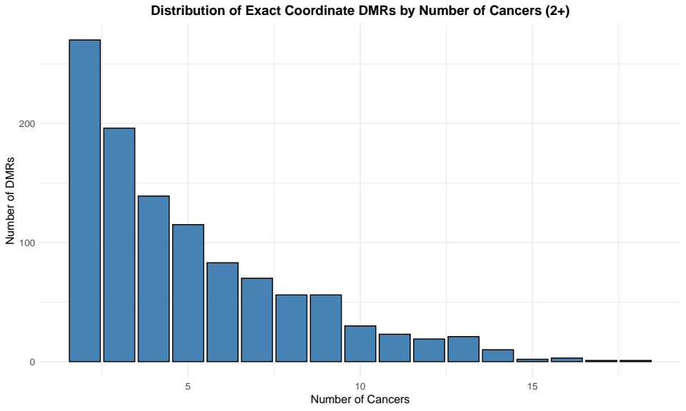
figure 3.5.1

The concordant DMRs were distributed across 476 distinct miRNAs, with substantial variations in the number of concordant DMRs per miRNA (figure 3.5.2). Among the miRNAs affected by the DMRs, hsa-mir-4251 displayed the highest frequency with 62 concordant DMRs present in 19 cancer types, 59 of them exhibiting hypomethylation patterns. Hsa-mir-4251 displayed most of the concordant DMRs in UCEC while BLCA, LIHC and LUSC followed closely with fewer DMRs. The following most affected miRNAs were hsa-mir-153-2, exhibiting 18 consistently hypomethylated DMRs across 18 cancer types with LUSC, BLCA, LIHC and UCEC being the cancers with the most DMRs. hsa-miR-7154 presented 15 consistently hypomethylated DMRs appearing across 17 cancer types. hsa-miR-7154 displayed the majority of its DMRs in BLCA, LUAD, READ and SARC. Also, hsa-mir-7160 showed 12 concordant DMRs, 11 of them hypomethylated and 1 hypermethylated, present in 18 cancers including BLCA and LIHC. The remaining 471 miRNAs revealed a significantly lower frequency of DMRs, most of them presenting only 1 or 2 DMRs in multiple cancers (figure 3.5.3).
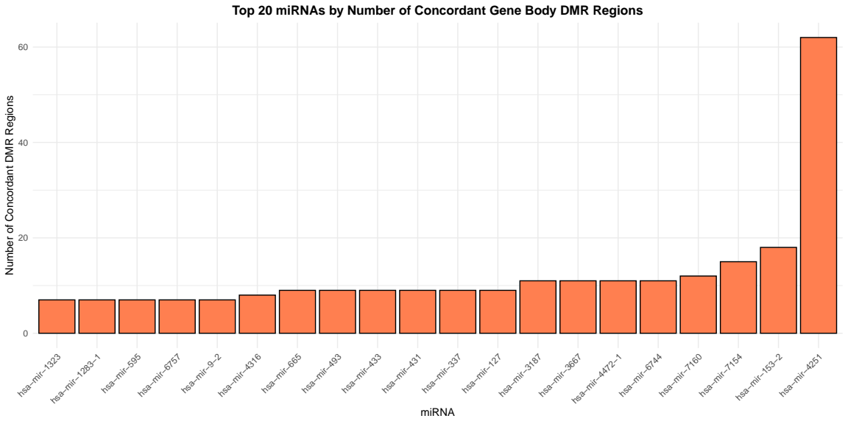

figure 3.5.2

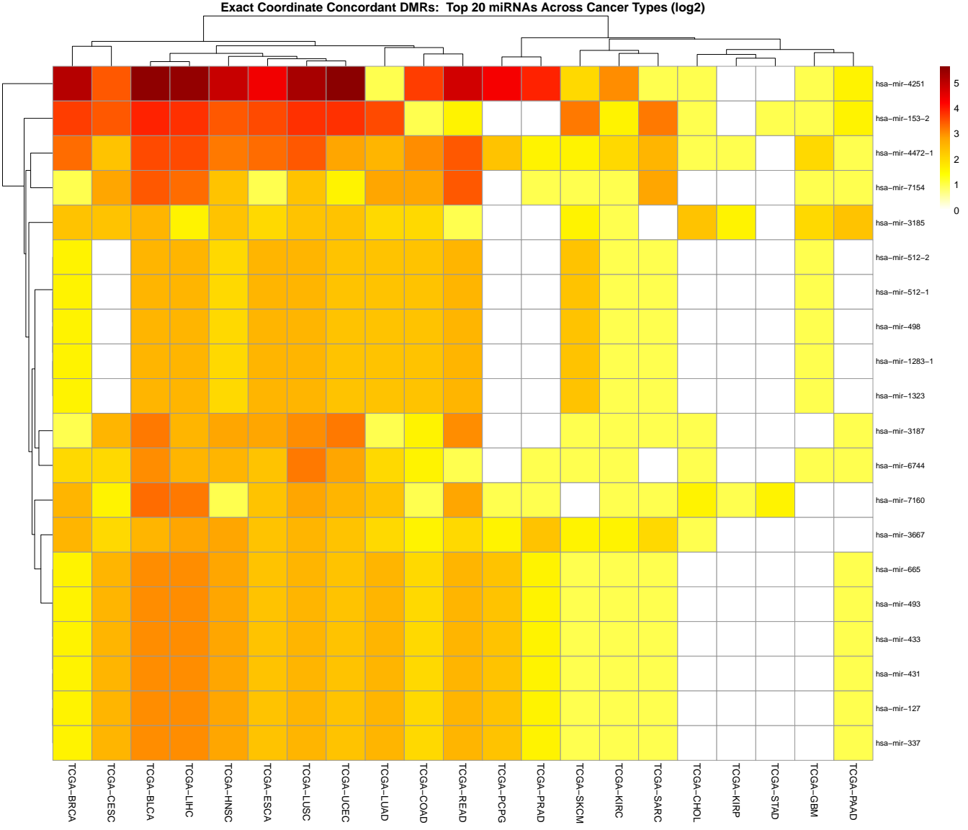

figure 3.5.3

The analysis also revealed a significant heterogeneity in the distribution of miRNA-associated concordant DMRs across the multiple cancer types, suggesting that the extent of methylation dysregulation can vary substantially across different cancer types. Most of the cancer types displayed between 39 and 492 concordant DMRs,excluding THYM which presented only 1 DMR, indicating a widespread methylation dysregulation.
BLCA was the cancer with the highest frequency of concordant DMRs, exhibiting 492 DMRs followed closely by UCEC with 469 DMRs, CESC with 436 DMRs, LIHC with 416 DMRs and LUSC with 409 DMRs.
In contrast, several cancers displayed lower frequencies of miRNA-associated concordant DMRs. For example, CHOL presented 267 concordant DMRs, while PAAD and PCPG exhibited 155 and 315 DMRs, respectively. The remaining cancer types, including THYM, STAD, SKCM, and SARC, showed the lowest frequencies, with THYM presenting only 1 concordant DMR, STAD 39 DMRs, SKCM 179 DMRs, and SARC 92 DMRs (figure 3.5.4).
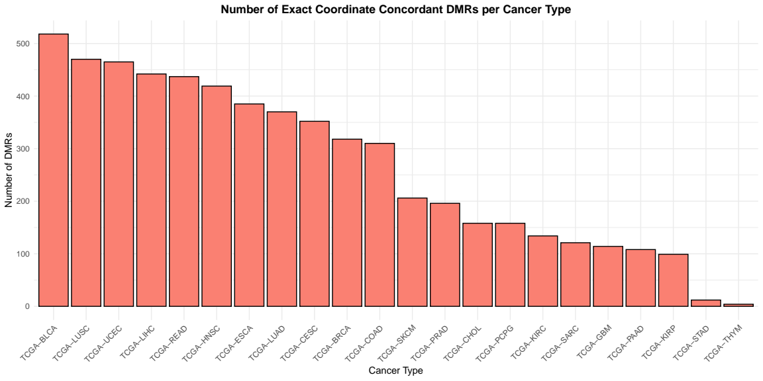
figure 3.5.4

Examination of methylation directionality in miRNA gene bodies revealed distinct cancer-specific patterns (figure 3. 5. 5). BLCA displayed 103 hypermethylated and 389 hypomethylated gene body DMRs, showing a pronounced hypomethylation bias with nearly four times more hypomethylated regions. LIHC exhibited 63 hypermethylated and 353 hypomethylated gene body DMRs, demonstrating the strongest hypomethylation predominance among all cancer types analyzed. LUSC showed 137 hypermethylated and 272 hypomethylated gene body DMRs, while READ presented 91 hypermethylated and 301 hypomethylated gene body DMRs, both reflecting substantial hypomethylation bias. UCEC displayed 175 hypermethylated and 294 hypomethylated gene body DMRs, indicating a moderate hypomethylation predominance. In contrast, CHOL exhibited 203 hypermethylated and 64 hypomethylated gene body DMRs, revealing the most pronounced hypermethylation bias with more than three times as many hypermethylated regions. PRAD showed 195 hypermethylated and 73 hypomethylated gene body DMRs, demonstrating strong hypermethylation predominance. KIRP presented 176 hypermethylated and 47 hypomethylated gene body DMRs, displaying marked hypermethylation bias. Several cancer types exhibited relatively balanced patterns, including BRCA with 181 hypermethylated and 185 hypomethylated gene body DMRs, CESC with 215 hypermethylated and 221 hypomethylated gene body DMRs, and ESCA with 163 hypermethylated and 175 hypomethylated gene body DMRs. Cancer types with minimal overall DMR alterations, such as THYM (1 hypomethylated), STAD (16 hypermethylated and 23 hypomethylated), and SARC (23 hypermethylated and 69 hypomethylated), showed limited but predominantly hypomethylated patterns in miRNA gene bodies.

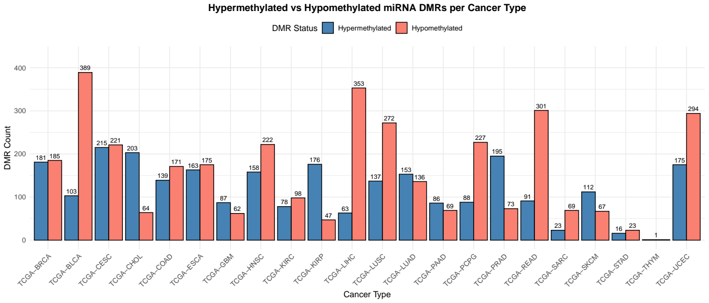
Figure 3.5.5

3.6 Coordinate-Based Identification of overlapping DMRs in miRNA Promoter Regions across different cancer types
To identify DMRs with consistent methylation patterns in miRNA regulatory regions across multiple cancer types, 22 TCGA cancer datasets were analyzed for significant DMRs overlapping with miRNA promoter regions. This analysis showed a total of 383 DMRs with identical genomic locations in at least 2 cancer types.
Of the 383 identified DMRs, 286 exhibited concordant methylation, with 155 DMRs being consistently hypermethylated and 131 DMRs being consistently hypomethylated, across all cancer types they appeared, while 97 displayed discordant methylation, meaning mixed methylation directions, both hypermethylated and hypomethylated, in the cancer types they were present in.
The distribution of concordant DMRs by the number of cancer types they were common in showed that 118 DMRs were shared between 2 cancer types, with progressively fewer DMRs shared across more cancer types (figure 3.6.1).
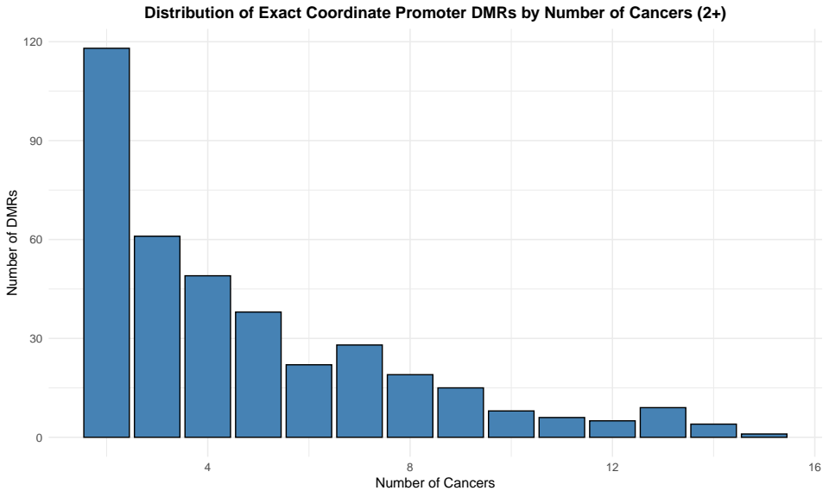
figure 3.6.1

The concordant DMRs were distributed across 290 distinct miRNAs, with substantial variations in the number of concordant DMRs per miRNA. Among the miRNAs affected by the DMRs, hsa-mir-935 displayed the highest frequency with 4 concordant DMRs present across 15 cancer types, all 4 of them exhibiting hypermethylation patterns. The following most affected miRNAs were hsa-mir-124-1, exhibiting 4 concordant DMRs across 10 cancer types with 3 hypermethylated and 1 hypomethylated DMR. Hsa-mir-6828 presented 3 consistently hypermethylated DMRs appearing across 14 cancer types. Hsa-mir-6068 showed 3 concordant DMRs, all hypermethylated, present in 16 cancer types including BLCA, BRCA, CESC, and HNSC. Multiple miRNAs from the chromosome 14 miRNA cluster (hsa-mir-369, hsa-mir-409, hsa-mir-410, hsa-mir-412, hsa-mir-541, and hsa-mir-656) each displayed 3 consistently hypomethylated DMRs across 13 cancer types. Additionally, hsa-mir-196a-1 showed 3 concordant DMRs, all hypermethylated, present in 16 cancers. Hsa-mir-543 presented 3 DMRs, all hypomethylated, appearing across 14 cancer types. The remaining miRNAs revealed variable frequencies of DMRs, with most presenting 1 or 2 concordant DMRs in multiple cancers (figure 3.6.2).
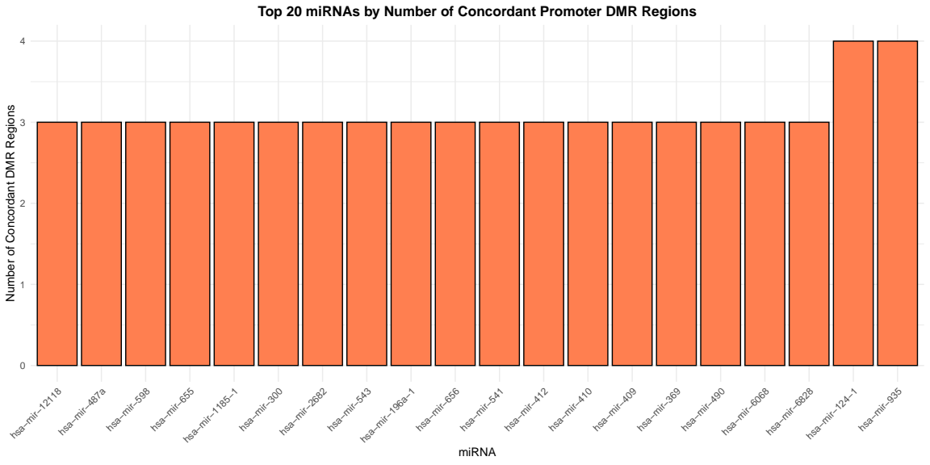

figure 3.6.2

The analysis also revealed significant heterogeneity in the distribution of miRNA promoter-associated concordant DMRs across the multiple cancer types, suggesting that the extent of promoter methylation dysregulation varies substantially across different cancer types. Most of the cancer types displayed between 6 and 162 concordant DMRs, excluding STAD which presented only 6 DMRs, indicating varied levels of promoter methylation dysregulation.
CESC was the cancer with the highest frequency of concordant promoter DMRs, exhibiting 162 DMRs, followed closely by BLCA with 141 DMRs, LUSC with 139 DMRs, HNSC with 135 DMRs, and LIHC with 132 DMRs. READ, UCEC, and ESCA also showed substantial frequencies with 125, 121, and 119 concordant promoter DMRs, respectively.
In contrast, several cancers displayed lower frequencies of miRNA promoter-associated concordant DMRs. For example, CHOL presented 70 concordant promoter DMRs, while SARC and PAAD exhibited 64 and 50 DMRs, respectively. The remaining cancer types, including STAD, KIRP, and PCPG, showed the lowest frequencies, with STAD presenting only 6 concordant promoter DMRs, KIRP 26 DMRs, and PCPG 38 DMRs (figure 3.6.3).
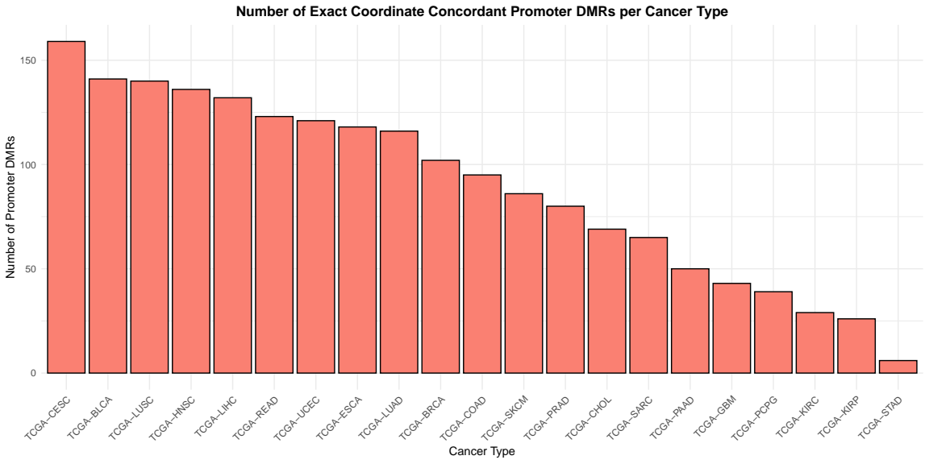
figure 3.6.3
Examination of methylation directionality in promoter regions revealed cancer-specific patterns (figure 3.6.4). CESC displayed 103 hypomethylated and 99 hypermethylated promoter DMRs, showing a relatively balanced pattern. BLCA exhibited 99 hypermethylated and 47 hypomethylated promoter DMRs, indicating a hypermethylation bias. UCEC showed 94 hypomethylated and 57 hypermethylated promoter DMRs, demonstrating a hypomethylation predominance. LIHC presented 49 hypermethylated and 103 hypomethylated promoter DMRs, reflecting strong hypomethylation. In contrast, PRAD displayed 75 hypermethylated and only 15 hypomethylated promoter DMRs, revealing the most pronounced hypermethylation bias among all cancer types analyzed. LUSC showed 58 hypermethylated and 172 hypomethylated promoter DMRs, while HNSC exhibited 69 hypermethylated and 113 hypomethylated promoter DMRs, both demonstrating hypomethylation predominance. The heatmap analysis of the top 20 miRNAs by concordant promoter DMRs across cancer types (figure 3.6.5) revealed distinct clustering patterns, with miRNAs from the chromosome 14 cluster (hsa-mir-369, hsa-mir-409, hsa-mir-410, hsa-mir-412, hsa-mir-541, hsa-mir-543, hsa-mir-655, hsa-mir-656) showing coordinated hypomethylation across multiple cancer types, while hsa-mir-935, hsa-mir-9903, hsa-mir-6068, hsa-mir-298, hsa-mir-196a-1, and hsa-mir-2682 displayed predominantly hypermethylation patterns across various malignancies.

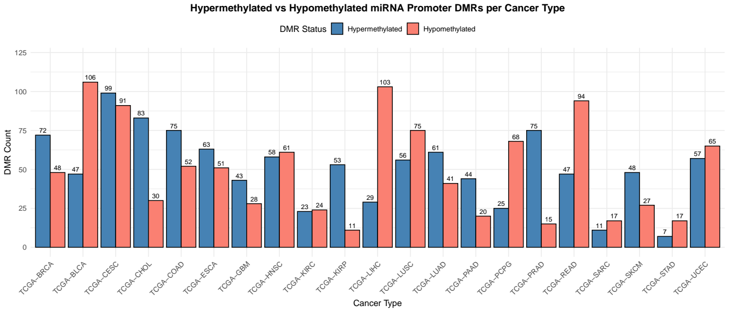
Figure 3.6.4

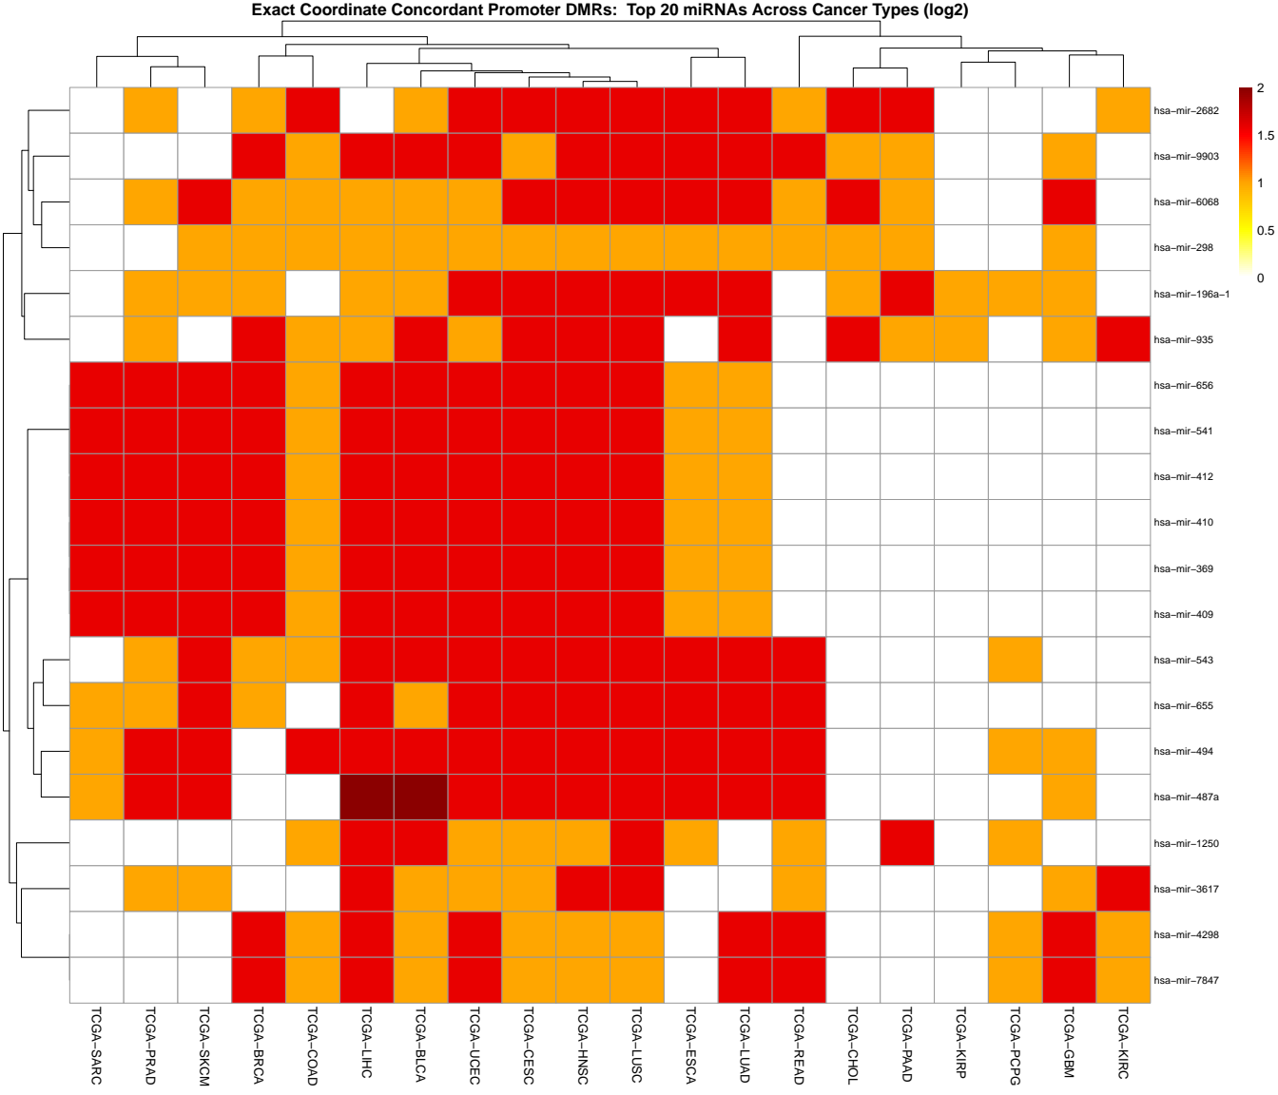
figure 3.6.5

Bibliography

- Jones PA, Baylin SB. (2007). The epigenomics of cancer. _{Cell}, 128(4):683–692. doi:10.1016/j.cell.2007.01.029
- The Cancer Genome Atlas Research Network., Weinstein, J., Collisson, E. et al. The Cancer Genome Atlas Pan-Cancer analysis project. Nat Genet 45, 1113–1120 (2013). https://doi.org/10.1038/ng.2764
- Illumina, Inc. (2012). Infinium HumanMethylation450 BeadChip Data Sheet:Epigenetics. Available at:https://www.illumina.com/documents/products/datasheets/datasheet_humanmethylation450.pdf
- Irizarry, R.A., Ladd-Acosta, C., Wen, B. et al. “The human colon cancer methylome shows similar hypo- and hypermethylation at conserved tissue-specific CpG island shores.” Nature Genetics 41, 178–186 (2009). https://doi.org/10.1038/ng.298

- Du, P., Zhang, X., Huang, C.C. et al. (2010). Comparison of Beta-value and M-value methods for quantifying methylation levels by microarray analysis. _{BMC Bioinfor}matics, 11:587. https://doi.org/10.1186/1471-2105-11-587
- Brorson, I.S., Eriksson, A.M., Høgestøl, E., Leikfoss, I.S., Harbo, H.F., Berge, T., Vitelli, V., Bos, S.D. (2022). Global DNA methylation changes in treated and untreated MS patients measured over time. Journal of Neuroimmunology, 364:577808.
ISSN 0165-5728. https://doi.org/10.1016/j.jneuroim.2022.577808
- Davalos, V., Moutinho, C., Villanueva, A., Boque, R., Silva, P., Carneiro, F., & Esteller, M. (2012). A microRNA DNA methylation signature for human cancer metastasis. Proceedings of the National Academy of Sciences, 109(13), 5755–5760. https://doi.org/10.1073/pnas.0803055105
- Goldfarb, T. et al. (2024) ‘NCBI REFSEQ: Reference Sequence Standards through 25 years of curation and annotation’, Nucleic Acids Research, 53(D1). doi:10.1093/nar/gkae1038.
- Perez, G. et al. (2024) ‘The UCSC genome browser database: 2025 update’, Nucleic Acids Research, 53(D1). doi:10.1093/nar/gkae974.
- Bartel, D.P. (2009) ‘MicroRNAs: Target recognition and regulatory functions’, Cell, 136(2), pp. 215–233. doi:10.1016/j.cell.2009.01.002.
- Huntzinger, E. and Izaurralde, E. (2011) ‘Gene silencing by micrornas: Contributions of translational repression and mrna decay’, Nature Reviews Genetics, 12(2), pp. 99–110. doi:10.1038/nrg2936.
- Peng, Y. and Croce, C.M. (2016) ‘The role of micrornas in human cancer’, Signal Transduction and Targeted Therapy, 1(1). doi:10.1038/sigtrans.2015.4.
- Lopez-Serra, P. and Esteller, M. (2011) ‘DNA methylation-associated silencing of tumor-suppressor micrornas in cancer’, Oncogene, 31(13), pp. 1609–1622. doi:10.1038/onc.2011.354.
- Corcoran, D.L., Pandit, K.V., Gordon, B., Bhattacharjee, A., Kaminski, N., and Brudno, M. (2009). Features of mammalian microRNA promoters emerge from polymerase II chromatin immunoprecipitation data. PLoS One 4(4), e5279. https://doi.org/10.1371/journal.pone.0005279
- Ozsolak, F., Poling, L.L., Wang, Z., Liu, H., Liu, X. S., Roeder, R.G., Zhang, X., Song, J. S., and Fisher, D.E. (2008). Chromatin structure analyses identify miRNA promoters. Genes & Development 22(22), 3172-3183. https://doi.org/10.1101/gad.1706508
- Lujambio, A., Ropero, S., Ballestar, E., Fraga, M. F., Cerrato, C., Setién, F., Casado, S., Suarez-Gauthier, A., Sanchez-Cespedes, M., Git, A., Spiteri, I., Das, P.P., Caldas, C., Miska, E., and Esteller, M. (2008). Genetic unmasking of an epigenetically silenced microRNA in human cancer cells. Cancer Research 68(4), 1424-1432. https://doi.org/10.1158/0008-5472.CAN-07-5960
- Di Leva, G., Garofalo, M., and Croce, C.M. (2014). MicroRNAs in cancer. Annual Review of Pathology: Mechanisms of Disease 9, 287-314. https://doi.org/10.1146/annurev-pathol-012513-104715
- Maksimovic, Jovana, Lavinia S. Phipson, and Alicia Oshlack. "A cross-package Bioconductor workflow for analysing methylation array data." F1000Research 5 (2016): 1281. https://f1000research.com/articles/5-1281/v2
- Ritchie, M.E. et al. (2015) ‘Limma powers differential expression analyses for RNA-sequencing and Microarray Studies’, Nucleic Acids Research, 43(7). doi:10.1093/nar/gkv007.
- Bhasin, J.M., Hu, B. and Ting, A.H. (2015) ‘Methylaction: Detecting differentially methylated regions that distinguish biological subtypes’, Nucleic Acids Research, 44(1), pp. 106–116. doi:10.1093/nar/gkv1461.

APPENDIX A
This appendix contains all code used in this study for data processing, quality control, differential methylation analysis and visualization. The code is written in R version 4.4.3 and is presented in the order following the pipeline.

